- \Operation\Monitoring, ambient air\Settings
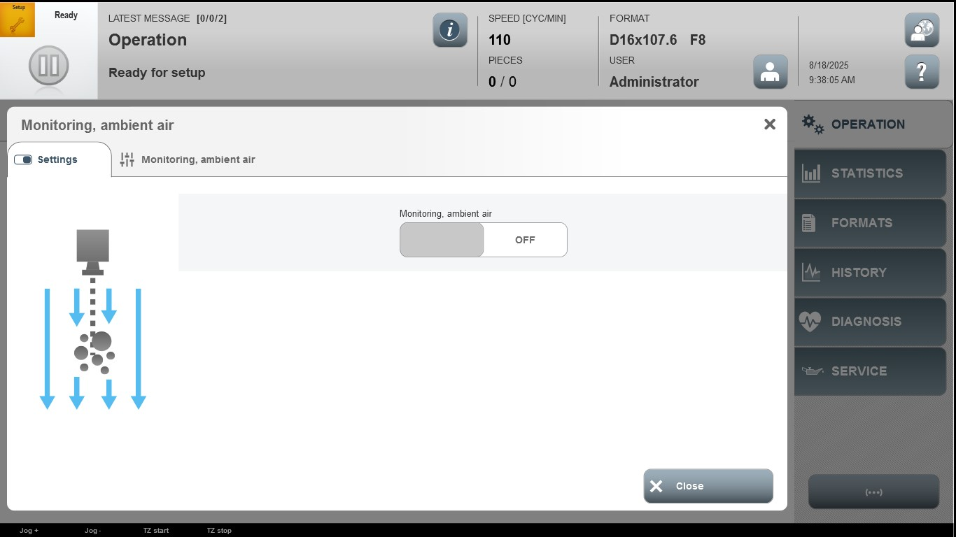

Acceptance criterion | Limits | Pass / Fail: Dev-No. | Date | Initials

